**Material selection for light weight springs**

Louis Zeng (lz406)

Fitzwilliam College, Lab Group 73

24th Nov 2019

**Introduction**

The purpose of the project is to select among steel, aluminium alloy and the polymer PMMA the most suitable material for a spring component which is to store elastic stain energy in bending and yet light weight.

**Experimental method**

Measuring weight of three material samples with similar geometric dimensions in order to assess weight performance. Then conduct three-point bending flexural test on each specimen in order to observe the flexural stress-strain response of the materials, which also provides the values for the modulus of elasticity in bending (flexural modulus, performance metrics for material in bending Ef) of each material. Larger flexural modulus indicate material is more ‘flexible’ under significant tensile loadings, in case elastic strain energy is 100% stored, the index would indicate the suitability as spring material.

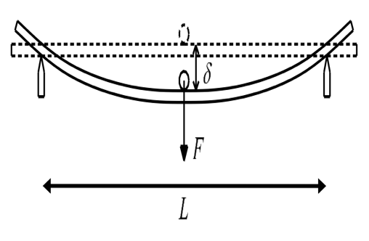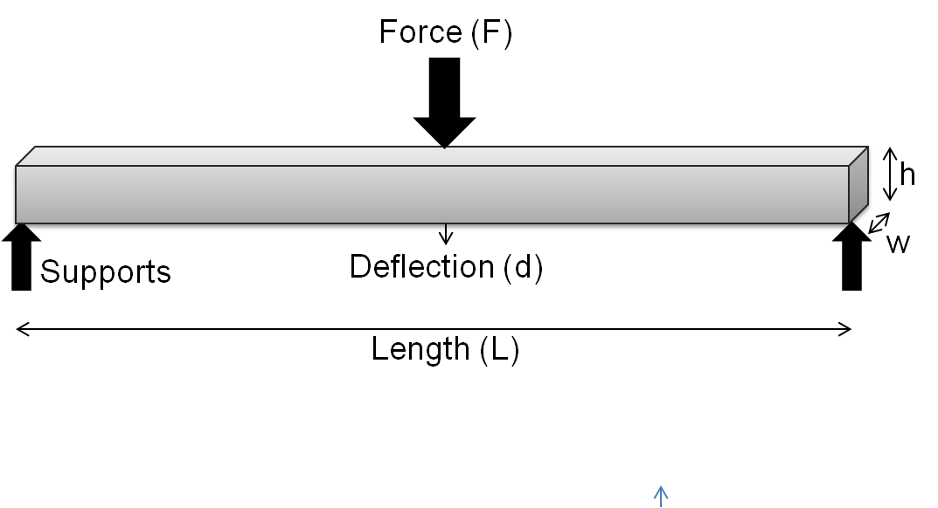

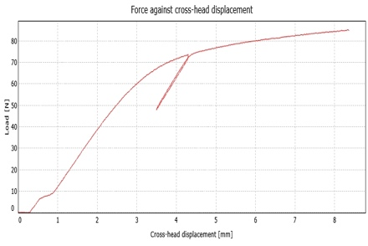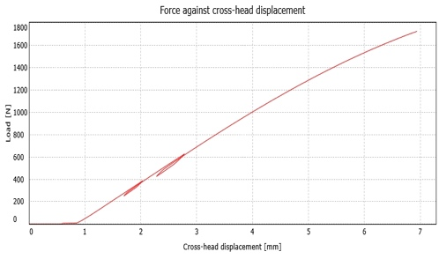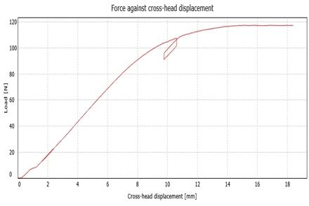**Results**

Force/displacement graph for Aluminium, PMMA, steel

|  |  |  |  |  |  |
| --- | --- | --- | --- | --- | --- |
| Material | Length/mm | Width/mm | Hight/mm | Mass/g | Flexural elasticity /Pa |
| Aluminium | 200 | 25.08 | 1.17 | 15.97 | $$5.69×{10}^{11}$$ |
| steel | 198 | 25.03 | 1.10 | 43.18 | $$1.17×{10}^{12}$$ |
| PMMA | 199 | 25.60 | 10.07 | 60.59 | $$1.96×{10}^{10}$$ |

Note: Ideally, flexural or bending [modulus of elasticity](https://en.wikipedia.org/wiki/Modulus_of_elasticity) is equivalent to the tensile modulus ([Young's modulus](https://en.wikipedia.org/wiki/Young%27s_modulus)) or compressive modulus of elasticity. In reality, these values may be different, especially for [polymers](https://en.wikipedia.org/wiki/Polymer).

**Conclusion**

In theory, both aluminium and steel could be utilised as spring components. As illustrated in the Force/displacement graph; when repeat reverse loading, both materials fully restore elastic strain energy, as shown as a straight load line on the graph. While PMMA not all elastic strain energy is recovered under such repetitive loading, which shown as a vertically shifted load line. Also considering other undiscussed material properties (e.g. brittleness), PMMA seem unlikely suitable for elastic spring applications.

Using equation $E=\frac{L^{3}F}{4wh^{3}d}$, I have calculated the corresponding flexural modulus of elasticity (also the performance metrics for materials in bending) for all three materials as tabulated above. Flexural modulus of elasticity for the steel sample is around twice the value of the aluminium counterpart, while it is also important to note that the density of steel is about thrice as much as Aluminium. It is clear that the choice between Aluminium and steel in our experiment selection is down to the balance between light weight and overall elasticity. If the application requires high elastic strain energy storage in bending, steel would be better choice with the sacrifice of weight.

Also, the possible shortcomings of the experiment include:

1.Calculated flexural modulus of elasticity for PMMA(polymer) may differ from real value.

2.The three-point bending test results are sensitive to specimen, loading geometry and strain rates.

The implications and causes of above shortcomings are beyond the scope of this project, and may be explored in further study.